Solve the following

Loops example

1. Print the following patterns using loop :

a.

*

**

***

****

b.

*

***

*****

***

*

c.

1010101

10101

101

1

QUERY :

delimiter //

create procedure pattern3(in n int)

begin

declare cnt int default n-1;

declare i int default 1;

declare j int default 1;

declare l int default 1;

declare str varchar(200) default '';

while i<=n do

set l = 2*cnt;

set j = 1;

while j<= l do

if(j%2) = 0 then

set str = concat(str,'0');

elseif(j%2)= 1 then

set str = concat(str,'1');

end if;

set j =j+1;

end while;

set cnt = cnt - 1;

set str = concat(str,'1','\n',lpad('',2,' '));

set i = i+1;

end while;

select str;

end //

delimiter ;

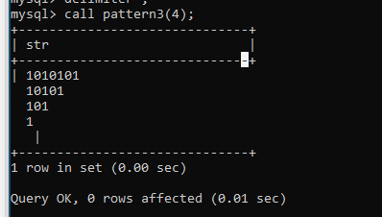

d.

1

1 2

1 2 3

1 2 3 4

1 2 3 4 5

QUERY :

delimiter //

create procedure pattern4(in n int)

begin

declare i int default 1;

declare j int default 1;

declare m int default 1;

declare str varchar(200) default '';

while i<=n do

set m = 1;

set j = 1;

while j<=i do

set str = concat(str,m);

set m = m+1;

set j = j+1;

end while;

set str = concat(str,'\n',lpad('',2,' '));

set i = i+1;

end while;

select str;

end //

delimiter ;

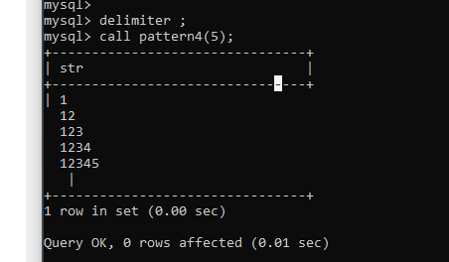

1.

2. write a procedure to insert record into employee table.

the procedure should accept empno, ename, sal, job, hiredate as input parameter

write insert statement inside procedure insert_rec to add one record into table

QUERY

delimiter //

create procedure insert_rec(peno int,pnm varchar(20),psal float,

pjob varchar(20),phire date,pdept int)

begin

insert into

emp values(peno,pnm,pjob,null,phire,psal,null,pdept);

end//

delimiter ;

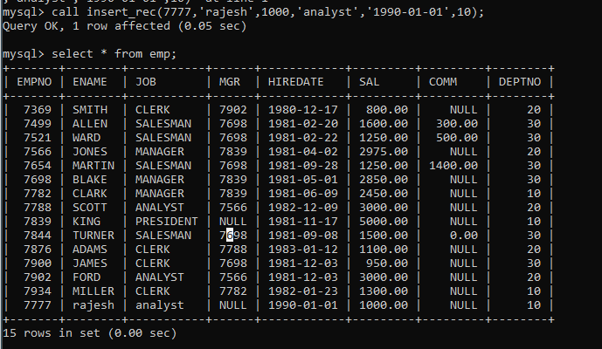

3. write a procedure to delete record from employee table.

the procedure should accept empno as input parameter.

write delete statement inside procedure delete_emp to delete one record from emp

table

QUERY :

mysql> delimiter //

mysql> create procedure delete_emp(peno int)

-> begin

-> DELETE FROM

-> emp where empno = peno;

-> end//

Query OK, 0 rows affected (0.09 sec)

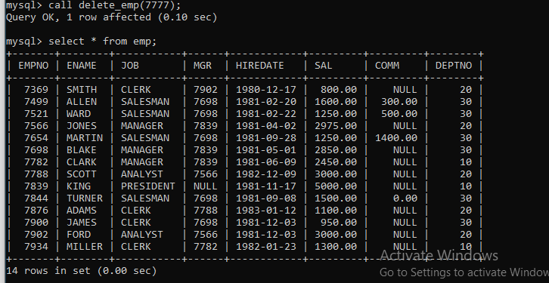

4. write a procedure to display empno,ename,deptno,dname for all employees with sal

> given salary. pass salary as a parameter to procedure

QUERY :

delimiter //

create procedure dIsplay_emp(psal int)

begin

select * FROM

emp where sal>psal;

end//

delimiter ;

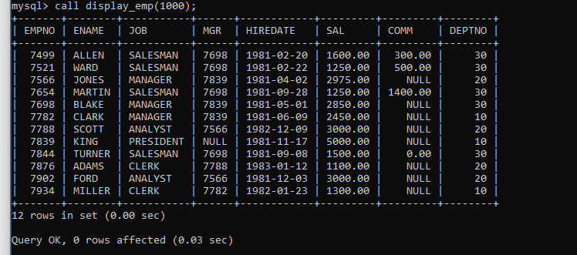

5. write a procedure to find min,max,avg of salary and number of employees in the

given deptno.

deptno --→ in parameter

min,max,avg and count ---→ out type parameter

execute procedure and then display values min,max,avg and count

QUERY :

delimiter //

create procedure emp_sal_info(pdeptno int,out mini float,

out maxi float,out avge float,out cnt int)

begin

select min(sal),max(sal),avg(sal),count(*) into mini,maxi,avge,cnt

from emp

where deptno = pdeptno

group by deptno;

end//

delimiter ;

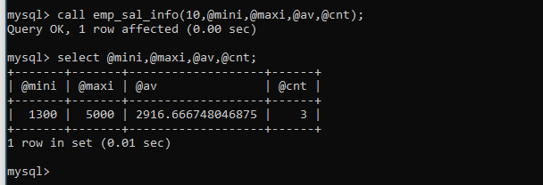

6. write a procedure to display all pid,pname,cid,cname and salesman name(use

product,category and salesman table)

QUERY :

delimiter //

create procedure prod_info()

begin

SELECT p.pid,p.pname,c.cid,c.cname,s.sname

from product p inner join

category c on c.cid = p.cid

inner join

salesman s on s.sid = p.sid;

end//

delimiter ;

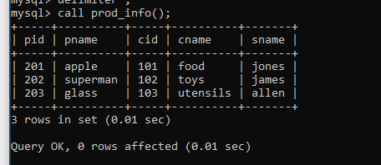

7. write a procedure to display all vehicles bought by a customer. pass cutome name as

a parameter.(use vehicle,salesman,customer and relation table)

8. Write a procedure that displays the following information of all emp

Empno,Name,job,Salary,Status,deptno

Note: - Status will be (Greater, Lesser or Equal) respective to average salary of their own

department. Display an error message Emp table is empty if there is no matching

record.

QUERY :

delimiter //

create procedure emp_status()

begin

declare pname,pjob,status varchar(20);

declare pempno,pdno int;

declare psal,av float;

declare vset int default 0;

declare empcur cursor for select empno,ename,sal,job,deptno from emp;

declare continue handler for NOT FOUND set vset = 1;

open empcur;

label1 : LOOP

fetch empcur into pempno,pname,psal,pjob,pdno;

if(vset =1) then

leave label1;

end if;

select avg(sal) into av

from emp where deptno=pdno;

if psal > av then

set status = 'greater';

elseif psal < av then

set status = 'lesser';

else

set status = 'equal';

end if;

select pempno,pname,psal,pjob,status,pdno;

end loop label1;

close empcur;

end//

delimiter ;

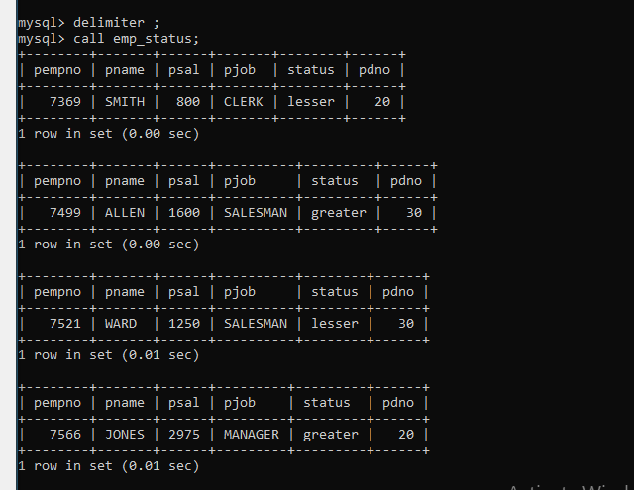

9. Write a procedure to update salary in emp table based on following rules.

Exp< =35 then no Update

Exp> 35 and <=38 then 20% of salary

Exp> 38 then 25% of salary

QUERY :

delimiter //

create procedure upd_sal()

begin

declare vexp,veno,vyr int;

declare hike float default 0;

declare vset int default 0;

declare empcur cursor for select empno,year(hiredate) from emp;

declare continue handler for NOT FOUND set vset = 1;

open empcur;

label1 : LOOP

fetch empcur into veno,vyr;

if(vset =1) then

leave label1;

end if;

set vexp = year(curdate()) - vyr;

if vexp between 36 and 38 then

set hike = 0.20;

elseif vexp > 38 then

set hike =0.25;

end if;

update emp

set sal = sal + sal*hike

where empno = veno;

end loop label1;

close empcur;

end//

delimiter ;

BEFORE: 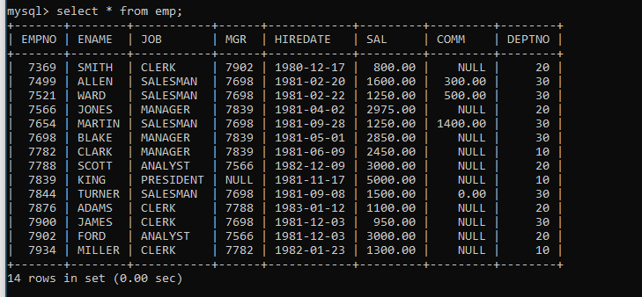

AFTER: 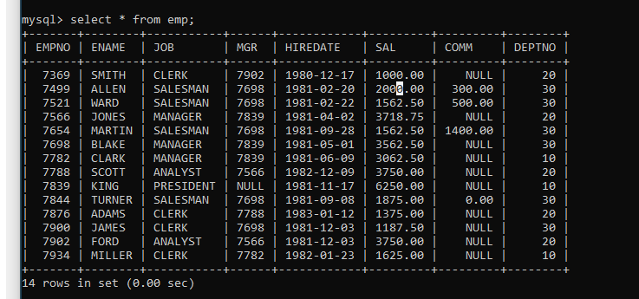

10. Write a procedure and a function.

Function: write a function to calculate number of years of experience of employee.(note:

pass hiredate as a parameter)

Procedure: Capture the value returned by the above function to calculate the additional

allowance for the emp based on the experience.

Additional Allowance = Year of experience x 3000

Calculate the additional allowance

and store Empno, ename,Date of Joining, and Experience in

years and additional allowance in Emp_Allowance table.

create table emp_allowance(

empno int,

ename varchar(20),

hiredate date,

experience int,

allowance decimal(9,2));

QUERY :

FUNCTION :-

delimiter //

create function num_exp(pdate date)

returns int

deterministic

begin

declare exp int default 0;

set exp = year(curdate())- year(pdate) ;

return exp;

end //

delimiter ;

PROCEDURE:-

delimiter //

create PROCEDURE calc_allowance()

begin

declare veno,vexp int ;

declare vname varchar(20);

declare vhire date;

declare vall decimal(9,2);

declare vset int default 0;

declare empcur cursor for select empno,ename,hiredate from emp;

declare continue handler for NOT FOUND set vset =1;

open empcur;

label1 : loop

fetch empcur into veno,vname,vhire;

if vset =1 then

leave label1;

end if;

select num_exp(vhire) into vexp;

set vall = vexp * 3000;

insert into emp_allowance values(veno,vname,vhire,vexp,vall);

end loop;

close empcur;

end //

delimiter ;

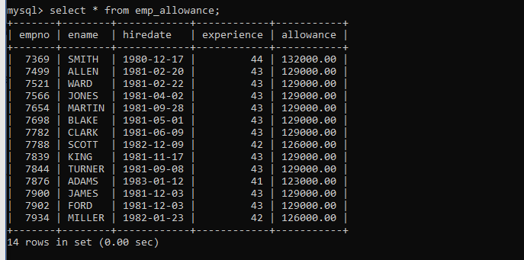

11. Write a function to compute the following. Function should take sal and hiredate

as i/p and return the cost to company.

DA = 15% Salary, HRA= 20% of Salary, TA= 8% of Salary.

Special Allowance will be decided based on the service in the company.

< 1 Year Nil

>=1 Year< 2 Year 10% of Salary

>=2 Year< 4 Year 20% of Salary

>4 Year 30% of Salary

QUERY:

delimiter //

create function calc_ctc(psal float,pdate date)

returns float

deterministic

begin

declare vexp int default 0;

declare vda,vhra,vta,vctc float ;

declare vsa float default 0;

set vexp = year(curdate())- year(pdate) ;

set vda = 0.15*psal;

set vhra = 0.20 * psal;

set vta = 0.08 * psal;

if vexp>=1 and vexp<2 then

set vsa = 0.10 * psal;

elseif vexp>=2 and vexp<4 then

set vsa = 0.20 * psal;

elseif vexp>4 then

set vsa = 0.30 * psal;

end if;

set vctc = vda+vhra+vta+vsa;

return vctc;

end //

delimiter ;

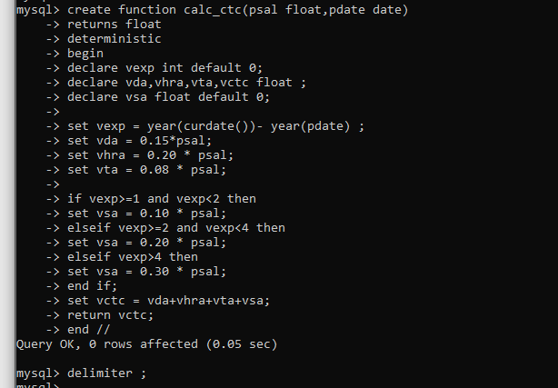

12. Write query to display empno,ename,sal,cost to company for all employees(note:

use function written in question 10)

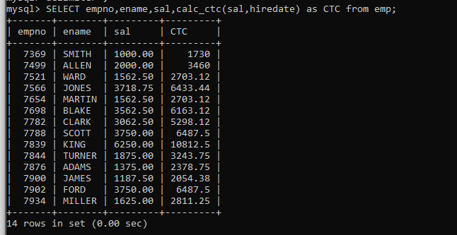

Q2. Write trigger

1. Write a tigger to store the old salary details in Emp _Back (Emp _Back has the

same structure as emp table without any

constraint) table.

(note :create emp_back table before writing trigger)

----- to create emp_back table

create table emp_back(

empno int,

ename varchar(20),

oldsal decimal(9,2),

newsal decimal(9,2)

)

(note :

execute procedure written in Q9 and

check the entries in EMP_back table after execution of the procedure)

QUERY :

delimiter //

create trigger empsal

before update on emp for each row

begin

insert into emp_back values(old.empno,old.ename,old.sal,new.sal);

end //

delimiter ;

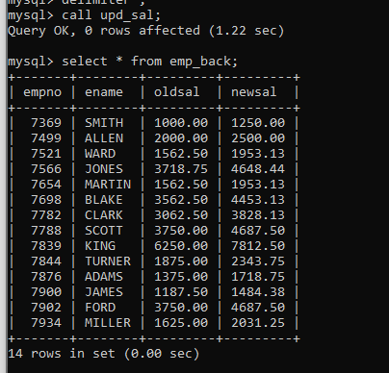

2. Write a trigger which add entry in audit table when user tries to insert or delete

records in employee table store empno,name,username and date on which

operation performed and which action is done insert or delete. in emp_audit table.

create table before writing trigger.

create table empaudit(

empno int,

ename varchar(20),

username varchar(20),

chdate date,

action varchar(20)

);

QUERY :

delimiter //

create trigger EMPINSERT

before INSERT on emp for each row

begin

insert into emp_audit values(new.empno,new.ename,new.ename,curdate(),'INSERT');

end //

delimiter ;

delimiter //

create trigger EMPUPD

before UPDATE on emp for each row

begin

insert into emp_audit values(old.empno,old.ename,old.ename,curdate(),'UPDATE');

end //

delimiter ;

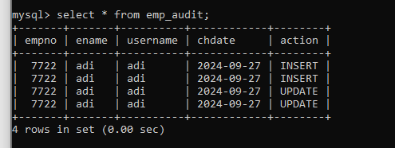

3. Create table vehicle_history. Write a trigger to store old vehicleprice and new vehicle

price in history table before you update price in vehicle table

(note: use vehicle table).

create table vehicle_history(

vno int,

vname varchar(20),

oldprice decimal(9,2),

newprice decimal(9,2),

chdate date,

username varchar(20)

)